Summer 2003
Undergrad Research Scholarships

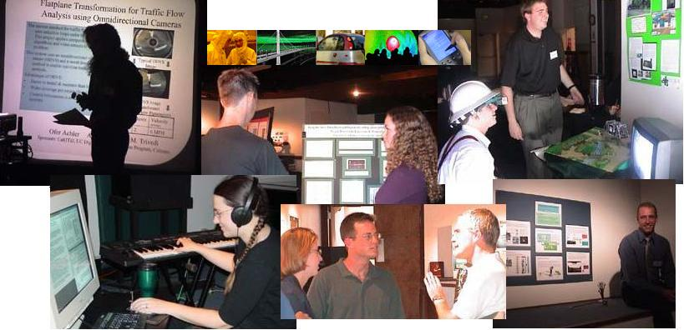

- 17 scholarships available for UCSD undergrads (students graduating spring 2003 are eligible)
- $4,000 each
- 10 weeks of summer research
- Apply online by 2:00 pm, February 28, 2003
- Offered by the California Institute for Telecommunications and Information Technology

Scholarship Details:
The UCSD Division of Cal-(IT)² plans to offer its third Undergraduate Research Scholarship program for the summer of 2003. This program provides talented undergraduates with concrete research experience to help them better define their career goals. The program is fashioned on the Research Experiences for Undergraduates program funded by the National Science Foundation. We expect to offer approximately 17 scholarships at $4,000 each for 10 weeks of full-time research.

Student scholars, in addition to conducting their research projects, participate in several meetings during the summer to learn about the institute, develop communication and leadership skills, and get to know each other. Former scholars indicate that the scholarships were important assets in their graduate school applications.

Application Information:
Eligible students are undergraduates in degree programs at UCSD, including students graduating the spring of 2003. The application deadline is Friday, February 28 at 2:00 pm. The awardees will be selected by the UCSD Division Director Ramesh Rao and the Cal-(IT)² layer leaders by the end of March.

To be the most competitive, applicants are strongly encouraged to
- review Cal-(IT)²’s Web site for more information about the institute.
- identify a faculty advisor that agrees to provide supervision.
- outline a proposed research project (use the field “Area(s) of research interest/proposed summer research project" on the Web application form).
- request a letter of recommendation from your faculty member to be sent to Stephanie Sides, ssides@ucsd.edu, no later than Monday, March 3, 2003.

